**План-конспект урока по английскому языку в 4 классе (Шпак И. Ф.)**

**Тема: Одежда для разных пор года**

**Цели занятия:**

**- обучающая:** обучение учащихся понимать основное содержание прослушанного и прочитанного текста, обучение учащихся строить связное и логичное высказывание с опорой на предложенную ситуацию общения.

**- развивающая:** развитие памяти, логического мышления, языковой догадки, развитие фонематического слуха, развитие навыков говорения, чтения и письма, развитие навыков индивидуальной, парной и групповой деятельности.

**- воспитательная:** воспитание культуры взаимоотношений со сверстниками на уроке, воспитание необходимости контролировать и оценивать свою деятельность на уроке, повышение интереса к изучению английского языка.

**Сопутствующие задачи:** закрепить ранее пройденный грамматический материал,контролировать усвоение прослушанного и прочитанного текста, мотивировать и побуждать учащихся к связному и логичному высказыванию.

**Оснащение:** записи на доске, наглядный материал (картинки, слова, транскрипция слов), мультимедийная презентация, аудио- и видеоматериал, раздаточный материал (карточки с заданиями).

**Содержание урока**

|  |  |  |  |  |  |
| --- | --- | --- | --- | --- | --- |
| **Этапы** | **Задача** | **Учитель** | **Учащиеся** | **Время** | **Приме-чание** |
| **I. Начало урока**  **1. Орга-низацион-ный этап** | Создать добро-  жела-  тельную атмос-  феру | - Good afternoon, pupils. I’m glad to see you. How are you? Are you ready for the lesson? Answer the questions, please:  - Who is on duty today?  - Who is absent today?  - What date is it today?  - What season is it now?  - What’s the weather like today?  Thanks for your answers. | Приветству-ют учителя, говорят, как  у них дела, настраи-  ваются на работу | 1 мин |  |
| **2. Введе-**  **ние в языковую ситуацию** | Создать условия для са-мостоя-тельного форму-  лирова-  ния темы учащи-  мися | An English proverb says: “There is no bad weather there are bad clothes.” Look at the pictures on the board and guess the theme of our lesson. So, the theme of our lesson is “Clothes for different seasons”.  What will we speak about today? Today we will speak about clothes for different seasons and clothes for different situations: for school, for walking and at home. | Внима-  тельно слушают учителя,  самостоя-  тельно  форму-  лируют  тему урока | 2 мин | На  доске  кар-  тинки |
| **3.Целе-полагание** | Поста-  новка целей и задач | What will we do at the lesson? You can use pictures for your answers.  Look at the screen and read the main aims of the lesson. Today we will revise the words on the topic “Clothes”, speak about clothes for different seasons and for different situations (for school, for walking and at home), develop speaking, writing, listening skills, do the projects and present them.  Today we have an unusual lesson. We will work into three teams. For each right answer I’ll give you smileys. And at the end of the lesson we will count them and we will get to know which team will be a winner. | Осознают поставлен-ную цель, готовятся к активному сотрудни-честву | 2 мин | На  экране  тема и  цели урока |
| **4. Провер-**  **ка домаш-него задания** |  | What did you do at home? Your hometask was to revise all the words on the topic “Clothes”. How well you did your hometask we will know during this lesson. | Cлушают учителя | 1 мин |  |
| **II. Основ-**  **ной этап**  **1.Фонети-ческая зарядка** | Активи-зация знаний  по теме | Now let’s revise the words on the topic “Clothes” and train our pronunciation.  Repeat the sounds after me and read the words.  Onthe board there is a rhyme  with the missing words.  Who wants to go to the board?  Match transcriptions with the words.  Fill in the words and read the rhyme.  This is my jumper.  These are my shoes.  These are my trousers.  They are blue.  Gloves on my hands.  Hat on my head.  Look at my T-shirt.  It is red. | Вместе с учителем произносят  английские  звуки и чи-тают слова  Заполняют  пропуски  в стихот-ворении.  Соединяют  транскрип-  цию со словами .  Читают  стихотво-рение | 2 мин | На доске  карточки  со сло-вами и их транск-рипция,  стихот-  ворение  с пропус-  ками  (транск-  рипция  вместо  слов)  Прило-жение1 |
| **2.Речевая зарядка** | Вызов мотива-ционной потреб-ности к высказы-ванию | Well, we revised the words on the topic “Clothes” and trained our pronunciation. Now let’s train our  speaking skills. Look at the screen. Read the questions.  -What do you usually wear at home?  - What do you usually wear for walking?  -What are you wearing now?  Ask each other. Work in pairs. | Читают вопросы на слайде и спраши-  вают друг друга | 3 мин | Презен-тация |
| **3. Обуче-ние**  **чтению**  **а) пред-**  **текстовый**  **этап** | Введение  в ситуа-  тивный  контекст | We wear different clothes in different situations and in different seasons. Now we will read “The advice when you choose clothes”. Look at the screen, read and answer the question: What clothes do we wear in different seasons? | Внима-  тельно слушают учителя | 1 мин | Презен-тация |
| **б) текс-товый**  **этап** | Развитие навыков  точного  понима-  ния  прочи-танного  текста | Let’s read the text one by one.  Be attentive, because after reading we will answer the question and do the task. | Читают  текст | 2 мин | Текст на слайде презен-тации |
| **в) после-тексто-**  **вый этап** | Контроль понима-ния  прочи-танного | Let’s check how you understood the text. Answer the questions, please: The first team: What clothes do we wear in winter? Put the pictures with winter clothes on the board.  The second team: What clothes do we wear in summer? Put the pictures  with summer clothes on the board.  The third team: What clothes do we wear in spring and in autumn? Put the pictures on the board.  Now let’s do the tasks on your  desks. Look at the cards. Remember the text and write the missing words. Work in groups.  Let’s check. Look at the screen. How many mistakes have you got?  I see you were very attentive and your answers were right.  If you have no mistakes you can take a smiley. | Отвечают  на вопросы и выполняют задание на карточке, проверяют свои ответы | 5 мин | Задание  на  карточке  Прило-жение 2  Презен-тация |
| **4. Зарядка**  **для глаз** | Снятие напря-жения,  предуп-реждение утомле-ния | I think you are tired. Let’s have  a rest and do exercises for your eyes.  Stand up, please…  One, two, three, four.  Look at the window,  Look at the door,  Look at the ceiling,  Look at the floor.  One, two, three, four.  Look left, look right.  Look up, look down.  Look around.  Look at your nose.  Look at that rose.  Close your eyes.  Open, wink and smile.  Thanks for your smiles. They are  very beautiful. | Вниматель-но слушают учителя, выполняют  зарядку  для глаз | 3 мин | Прило-жение 3 |
| **5. Обуче-ние восприя-тию и понима-**  **нию ино-язычной речи на слух.**  **(Аудиро-вание)** | Развитие умений понима-ния ино-язычной речи на слух | Our English friends, Mike, Liz  and Twinky want to tell you about  their favourite clothes.  The first team will listen about Mike’s favourite clothes.  The second team will listen  about Twinky’s favourite clothes.  The third team will listen about Liz’s favourite clothes.  Listen and answer: What are their favourite clothes?  Teams, answer the questions, please:  -What are Mike’s favourite clothes?  -What are Twinky’s favourite  clothes?  -What are Liz’s favourite clothes?  Find these clothes on the board and match them with the photos of our English friends.  Let’s listen again and answer: What colour are their favourite clothes?  Where do they wear them? When do they wear their favourite clothes?  Write your answers on the cards.  Exchange the cards. Look at the screen and check your answers. How many mistakes have you got? If you have no mistakes you can take a smiley. | Вниматель-но слушают аудио  запись, отвечают на вопросы учителя, выполняют  индиви-дуально  задания на карточках. | 5 мин | Аудио запись.  На доске фотогра-фии  героев и их любимая  одежда  Прило-жение 4 |
| **7. Физми-нутка** | Снятие напря-жения, подня-тие настрое-ния | Let’s have a rest.  Let’s get dressed with Mike.  Watch the video, sing and  dance together. | Смотрят  видео,  поют, выполняют простые движения | 3 мин | Видео |
| **8. Приме-**  **нение зна-**  **ний и уме-**  **ний в**  **новой**  **ситуации** | Развитие  умения  исполь-зовать изу-  ченный мате-риал в новой ситуа-ции | We have spoken a lot about clothes today. It’s time to do the projects.  I’ll give you cards with the picture of a boy and of a girl.  The first team will make the design of winter clothes. The second team will make the design of summer clothes.  And the third team will make the design of spring and autumn clothes.  Make the design of clothes and present it your classmates and our guests.  Are you ready? Put your projects on the board an present them your classmates and our guests. | Выполняют проекты в группах. Рисуют одежду и пишут описание к ней. | 8 мин | Прило-жение 5 |
| **III. Зак-лючи-тельный этап**  **1.Объяс- нение домаш-**  **него задания** | Зна-комство  с содер-жанием домаш-  него заданияи инст-рукцией выпол-нения | Your hometask is: PB p. 66 ex. 2.  At home you will do the project «My favourite clothes». You should draw the clothes you like and write the description of your outfit on a separate sheet of paper. Write when you can wear these clothes (in winter, in summer, in spring or in autumn). And write where can you wear these clothes (for school, for a party and for walking).  If you want to have 9 or 10 you should learn your project by heart. | Вниматель-но слушают у инструк-  цию выполнения домашнего задания, записывают з в дневник | 2 мин |  |
| **2. Выстав-ление отметок** | Оценка резуль-татов учебной деятельности | How many smileys have you got? Let’s count. Which team is a winner? Great! You were very active and your answers were excellent. What is your mark today?  I agree (I disagree) with you, because… | Выстав-  ляют сами себе  отметку и слушают оценку учителя | 2 мин |  |
| **3. Реф-**  **лексия** | Подведение итога работы урока  с точки зрения постав-ленных целей | We have spoken a lot about clothes today. Look at the screen, remember our aims of the lesson and answer: What did you do at the lesson?  Was this theme interesting for you? What was difficult for you? What did you like at the lesson?  I’m satisfied with your work today.  Your answers were excellent!  Thank you for your work, my friends. Good-bye! | Слушают учителя.  Отвечают  на вопросы учителя. Прощаются | 3 мин |  |

**Приложение 1**

**(Речевая зарядка)**

**This is my [ˈʤʌmpə].**

**These are my**  **[ʃuːz] .**

**These are my [ˈtraʊzəz] .**

**They are blue.**

**[glʌvz] on my hands.**

**[hæt] on my head .**

**Look at my [ˈtiː.ʃɜːt] .**

**It is red.**

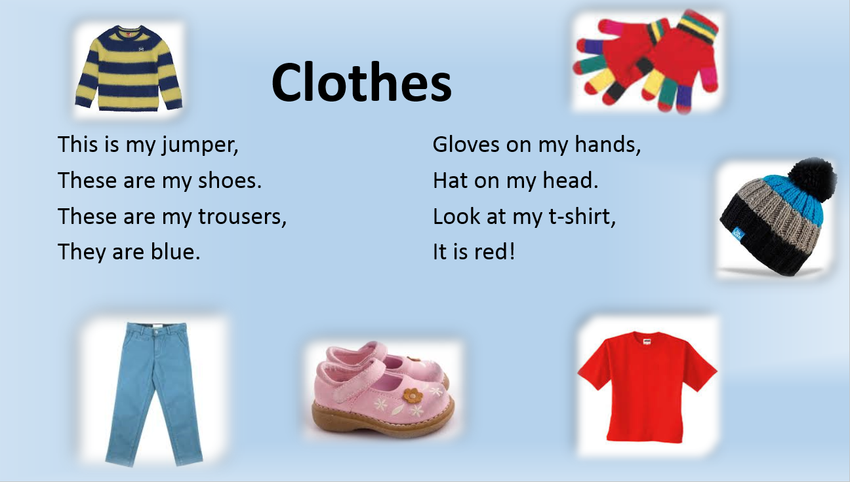

**Приложение 2**

**(Обучение чтению)**

**The advice when you choose clothes**

***party, four, clothes, autumn , shorts, wear, sweaters, put on, coats, gloves.***

**There are ... seasons in the year. Each of them brings different weather and different clothes. In summer people usually wear T-shirts and … , blouses and skirts, shoes or sandals. In spring and … they usually … warm clothes: jeans and trousers, … and jackets, coats, hats. In winter they wear fur … and fur caps, high boots and mittens or … .**

**When you don`t know what to … , think what is good at the sports ground, at school and what is good at the … . When you buy … , try them on, make sure that they are your size, that they suit you well and that you like their colour.**

**The advice when you choose clothes**

**There are four seasons in the year. Each of them brings different weather and different clothes. In summer people usually wear T-shirts and shorts, blouses and skirts, shoes or sandals. In spring and autumn they usually put on warm clothes: jeans and trousers, sweaters and jackets, coats, hats. In winter they wear fur coats and fur caps, high boots and mittens or gloves.**

**When you don`t know what to wear, think what is good at the sports ground, at school and what is good at the party. When you buy clothes, try them on, make sure that they are your size, that they suit you well and that you like their colour.**

**Приложение 3**

**(Зарядка для глаз)**

**One, two, three, four.**

**Look at the window,**

**Look at the door,**

**Look at the ceiling,**

**Look at the floor.**

**One, two, three, four.**

**Look left, look right.**

**Look up, look down.**

**Look around.**

**Look at your nose.**

**Look at that rose.**

**Close your eyes.**

**Open, wink and smile.**

**Приложение 4**

**(Аудирование)**

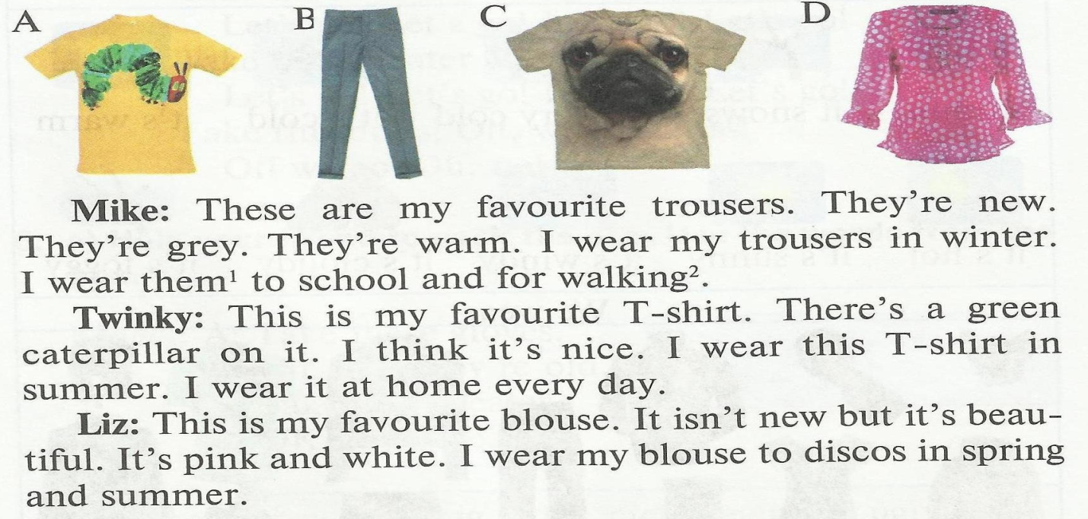

1. **What are Mike’s favourite clothes? ________________________________**
2. **What colour are his favourite clothes?_______________________________**

**3. When does Mike wear his favourite clothes?__________________________**

**4. Where does he wear his favourite clothes?____________________________**

**1. What are Twinky’s favourite clothes? ______________________________**

**2. What colour are his favourite clothes?_______________________________**

**3. When does Twinky wear his favourite clothes?________________________**

**4. Where does he wear his favourite clothes?____________________________**

**1. What are Liz’s favourite clothes? __________________________________**

**2. What colour are her favourite clothes?_______________________________**

**3. When does Liz wear her favourite clothes?___________________________**

**4. Where does she wear her favourite clothes?___________________________**

**1. What are Mike’s favourite clothes? – Trousers.**

**2. What colour are his favourite clothes? – Grey.**

**3. When does Mike wear his favourite clothes? – In winter.**

**4. Where does he wear his favourite clothes? – To school and for walking.**

**1. What are Twinky’s favourite clothes? - A T-shirt.**

**2. What colour are his favourite clothes? – Yellow and green.**

**3. When does Twinky wear his favourite clothes? – In summer.**

**4. Where does he wear his favourite clothes? – At home.**

**1. What are Liz’s favourite clothes? - A blouse.**

**2. What colour are her favourite clothes? - Pink and white.**

**3. When does Liz wear her favourite clothes? - In spring and in summer.**

**4. Where does she wear her favourite clothes? - To discos.**

**Приложение 5**

**(Проект)**

**In winter (In summer / In autumn and in spring)**

**boys and girls can wear__________________________**

**These clothes are very (good / comfortable / warm… )**

**You can wear these clothes (for walking / at home / to the party/ to the discos) __________________________**

