**ПЛАН-КОНСПЕКТ УРОКА АНГЛИЙСКОГО ЯЗЫКА В 8 КЛАССЕ**

**ПО ТЕМЕ “SCHOOLS IN GREAT BRITAIN ”**

**Тема**: Schools in Great Britain

**Цель:** создание для учащихся условий проявления коммуникативных умений в различных видах речевой деятельности

**Задачи:**

Организовать работу по развитию навыков ознакомительного чтения с элементами изучающего, совершенствованию навыков восприятия и понимания речи на слух, создать условия для развития навыков монологической речи в процессе решения коммуникативных задач.

Учить детей самостоятельно приобретать необходимую информацию, работать в команде.

Способствовать поддержанию и повышению интереса к дальнейшему изучению английского языка

**Применяемые технологии**: здоровьесберегающее обучение, проектная

|  |  |  |  |
| --- | --- | --- | --- |
| **Этап** | **Задача этапа** | **Содержание урока** | |
| **Учитель** | **Учащиеся** |
| 1 | 2 | 3 | 4 |
| Организа-ционно-мотиваци-онный (warm up) | Введение в атмосферу иноязычного общения.Создание доброжелательной атмосферы, способствующей дальнейшему сотрудничеству и последующему общению | Good morning, dear boys and girls. Sit down, please. I am glad to see you cheerful and healthy. To be healthy you should not only work but have a rest too. By the way what do you like doing in your free time? | Учащиеся приветствуют учителя. Рассказывают о своих хобби. |
| Активизация лексических единиц по теме, формулировка темы учащимися | OK. You see that some hobbies are very useful and relaxing. What about doing crosswords? Who likes doing them? OK. I’d like you to do this one. If you do it right, you’ll know the theme of the lesson. (Приложение 1)  So, what is the theme of the lesson? | Учащиеся решают кроссворд, проверяют правильность выполнения задания, и самостоятельно формулируют тему урока, появившуюся по вертикали кроссворда. |
| Определение учащимися целей и задач урока | Now I’d like you to look at these pictures. (на фото различные школы Великобритании) (Приложение 2) What can you see here? Yes. You can see different schools of Great Britain. So, what is the main aim of our lesson in your opinion? Yes, you are right. Today we are going to speak about different schools in Great Britain, point out their similarities and differences and compare them with our school. | Учащиеся формулируют цель и задачи урока. |
| Познава-тельный | Повышение эмоционального состояния учащихся для формирования мотивационной готовности к дальнейшей работе | Look at this photo. (Приложение 3) You can see our school. Now let’s play a **game**. You are divided into two teams. You must complete the sentence: My school…For each correct sentence the team gets a point. If there is a vocabulary word in a sentence, the team gets two points. | Учащиеся делятся на две команды, продолжают предложение. За каждое правильное предложение – балл. Если используется лексика раздела – 2 балла. |
| Создание интереса и мотивации к работе с текстом через опору на личный опыт. Активизация речевых навыков. | Now let’s summarize everything you have just said about your school. What is school for you? Sort out the phrases to make true sentences (Приложение 4) | Учащиеся выполняют задание: моя школа – это место, где я…и затем читают полученные предложения |
| Развитие навыков понимания прочитанного | Now it’s time to read some texts about different schools in Great Britain, compare them and say what they have in common and how they differ. We will have three groups to make our work more interesting. You must read the text and fill in the chart (Приложение 5) | Учащиеся делятся на 3 группы, читают текст и заполняют таблицу в группе. |
| Контроль-но-рефлек-сивный | Контроль понимания прочитанного с целью развития устной речи | Now let’s check up your understanding of the texts. You must ask the questions from the chart about another group’s school to share your opinions.  Now you will say the information about your school and your opponents must say if it is true or false. (Приложение 6) | Учащиеся задают вопросы из таблицы любой команде, любому участнику.  Затем они говорят о своей школе любое предложение, а другая команда должна решить – верно это или не верно. |
| Коррекци-онно-обобща-ющий с одновре-менной релакса-цией | Совершенствование навыков восприятия и понимания речи на слух и снятие усталости и напряжения, которые связаны с умственной нагрузкой | Now let’s close your eyes and listen to the film about some British school. You must recognize it. Now let’s watch the film about this school. Were you right? (Window on Britain. Eton school) | Учащиеся сначала слушают фильм о школе в Итоне, закрыв глаза. Они должны догадаться, о какой школе идет речь. Затем они смотрят этот фильм и слушают музыку. |
| Физкульт-минутка (moving activity) |  | I see you are a little bit tired. Let’s relax and do this exercise. I am going to say to you some sentences about this or that school. When you hear the information about your school your group must stand up. | Учащиеся слушают предложения о разных школах Великобритании. Услышав информацию о своей школе, вся группа встает |
| Работа над проектом (working on the project) | Обучение самостоятельному приобретению необходимой информации, работе в команде | Now you have to prepare a project in your groups. What is the topic of your project? Look at your chart again. You have the information about 3 British schools, but you have nothing about your school. You must read the instruction how to do the project. Then choose the form of your project and distribute the topics among the group mates. Write your part of the project. Use the texts and exercises you have done in this unit and the material of today’s lesson. | Учащиеся работают над проектом:  1 шаг – определение темы проекта – My school  2 шаг – формулировка проблемы – There is no information about our school in the textbook.  3 шаг – чтение инструкции как работать над проектом.  4 шаг – разбивка на подтемы: general information…  5 шаг – формирование групп 2  6 шаг – распределение подтем среди членов группы  7 шаг – сбор информации индивидуально (использование материалов учебника, рабочих тетрадей..)  8 шаг – написание своей части проекта  9 шаг - переработка информации и обсуждение  (10 шаг – систематизация и подготовка презентации  11 шаг – подготовка творческих отчетов, презентация – домашнее задание)  (12 шаг – вывод и рецензирование  13 шаг – рефлексия – на следующем уроке) |
| Рефлек-сивно-оценочный | Объяснение домашнего задания | Now open your record-books and write down your home task. Your home task is to prepare visuals for your project My school | Учащиеся записывают домашнее задание в дневники |
| Формирование у учащихся способностей анализировать и делать выводы.  Рефлексия | We have come to the end of our lesson. What do the three British schools and our school have in common? How are they different?  What school would you like to go to and why? | Учащиеся отвечают на вопросы учителя.  Выбирают школу, в которую бы они хотели пойти и говорят почему |
| Оценка и самооценка активности и работы учащихся на уроке | Think about your activities at the lesson. Describe them in 5 lines: line 1 – a noun, your main activity; line 2 – two adjectives true to your attitude, emotional state; line 3 – three verbs characterizing your activities; line 4 – one sentence statement; line 5 – one noun showing your own perspective. As for me I’m quite satisfied with your work at the lesson today. Your work was great. I liked it very much. Thank you for your participation. | Учащиеся слушают учителя и пишут ответы на листочках |

Приложение 1

**Do the crossword**

|  |  |  |  |  |  |  |  |  |  |  |  |  |  |  |
| --- | --- | --- | --- | --- | --- | --- | --- | --- | --- | --- | --- | --- | --- | --- |
|  | | | | | | | 1. |  |  |  |  |  |  |  |
|  | | | 2. |  | |  |  |  |  |  |  | | | |
|  | | | | 3. | |  |  |  |  |  |  |  | | |
|  | | 4. |  |  | |  |  |  |  |  |  |  | | |
| 5. |  |  |  |  | |  |  |  |  |  | | | | |
|  | 6. |  |  |  | |  |  |  |  | | | | | |
|  | | | | | | | 7. |  |  |  |  |  |  |  |
|  |  | | |  | | | |
| 8. |  | |  |  |  |  |
|  | | | | | | | 9. |  |  |  |  |  |  | |
| 10. |  |  |  |  |  |  |  |
|  | | 11. |  |  |  | |  |  |  |  | | | | |
|  | | | | | 12. | |  |  |  |  |  |  |  |  |
| 13. | |  |  |  |  | | | | |
| 14. |  |  |  | |  |

1. A school in which most or all the students live and study
2. A place where you can borrow books and textbooks
3. A sport game which is very popular in Great Britain
4. A table with subjects and time
5. It’s something that has existed for a long time
6. Language No 1 in the world
7. Children like them very much because they don’t have lessons then
8. It lasts 45 minutes
9. The area of land where the main buildings of a school, college or university are situated
10. It must be done at home
11. Students must wear it at school
12. You can surf the Internet using it
13. You can do outclass activities there
14. You learn to solve problems and do sums at this lesson

**Key:**

|  |  |  |  |  |  |  |  |  |  |  |  |  |  |
| --- | --- | --- | --- | --- | --- | --- | --- | --- | --- | --- | --- | --- | --- |
|  | | | | | | **B** | o | r | d | i | n | g |  |
|  | | | l | i | b | **r** | a | r | y |  | | | |
|  | | | | c | r | **i** | c | k | e | t |  | | |
|  | | t | i | m | e | **t** | a | b | l | e |  | | |
| t | r | a | d | i | t | **i** | o | n |  | | | | |
|  | E | n | g | l | i | **s** | h |  | | | | | |
|  | | | | | | **h** | o | l | i | d | a | y | s |
|  |  | | |  | | | |
| l | e | **S** | s | o | n |
|  | | | | | | **c** | a | m | p | u | s |  | |
| **h** | o | m | e | w | o | r | k |
|  | | u | n | i | f | **o** | r | m |  | | | | |
|  | | | | | c | **o** | m | p | u | t | e | r |  |
| c | **l** | u | b |  | | | | |
| m | a | t | h | **s** |

Приложение 2

**ETON SCHOOL**

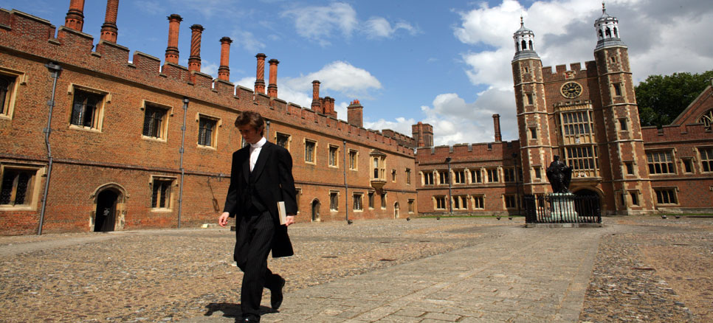

**HARROW SCHOOL**

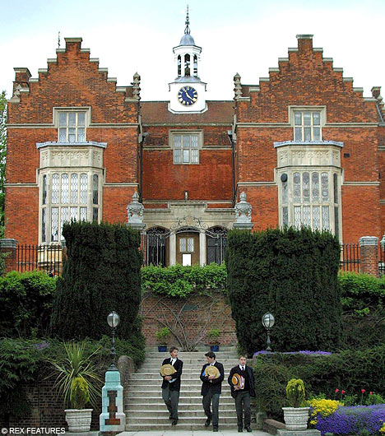

**BADMINTON SCHOOL**

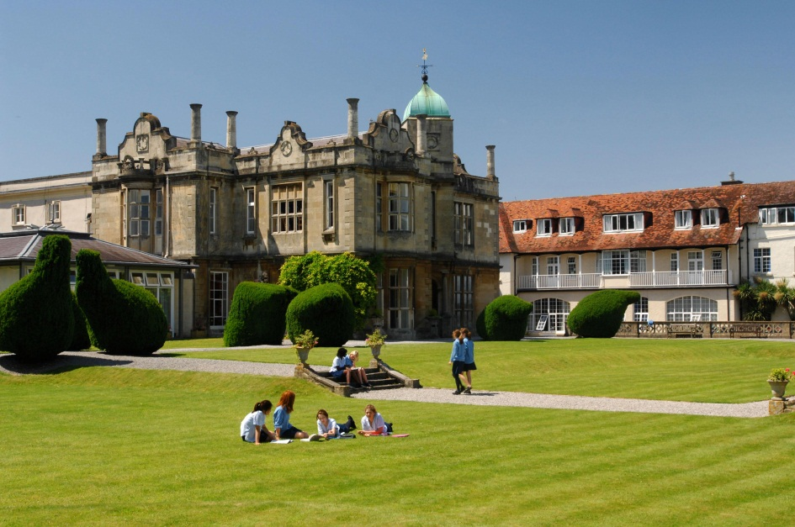

Приложение 3

**OUR SCHOOL**

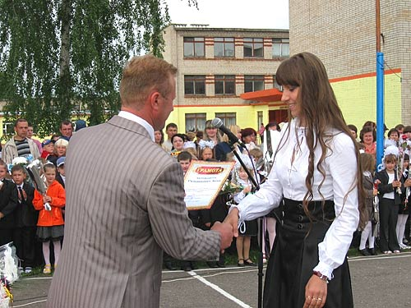 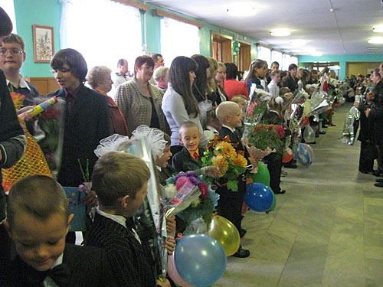 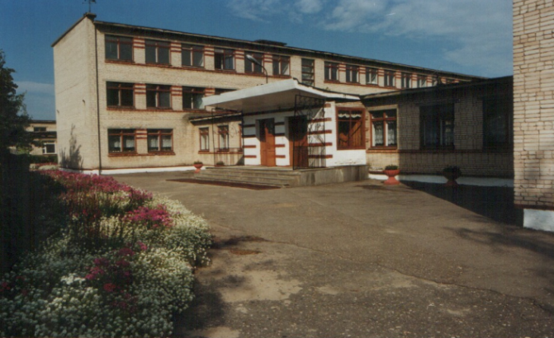 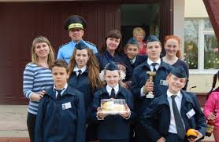

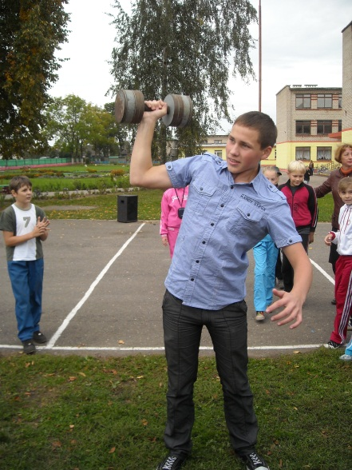 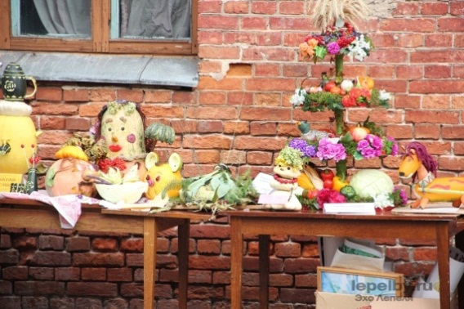 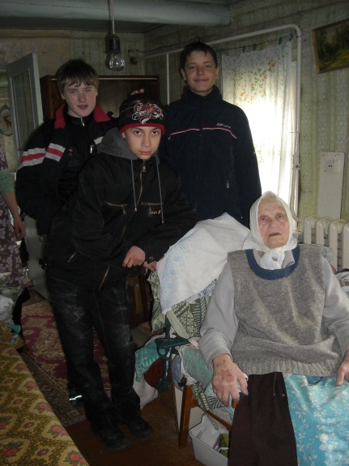

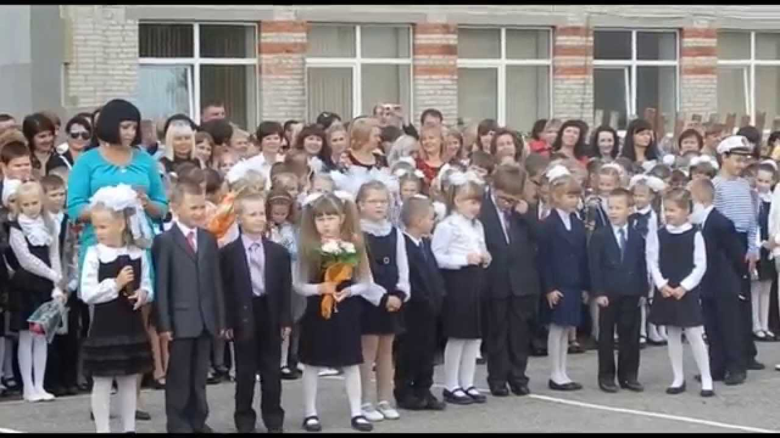 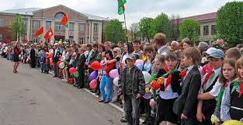

Приложение 4

*What is school? Sort out the phrases to make true sentences about you*

**School is a place where you…**

Learn __________________________________________________________________________________________________________________________________________________________________________________________________________________________________________________________________________________________________________________________________________

Develop __________________________________________________________________________________________________________________________________________________________________________________________________________________________________________________________________________________________________________________________________________

Have __________________________________________________________________________________________________________________________________________________________________________________________________________________________________________________________________________________________________________________________________________

lots of information about life nature and the world to solve problems

new skills to use in life how to get on with other people best friends

positive thinking how to work together tests and exams a lot of fun

to respect each other your talents and abilities a good chance to do sports

about yourself modern facilities for learning talents and skills

Приложение 5

|  |  |  |  |  |
| --- | --- | --- | --- | --- |
| question | **Eton** | **Harrow** | **Badminton** | **My school** |
| 1. What type of school is it? 2. Is it a boarding school? 3. Is it modern or old? 4. Where is it situated? 5. Do they have to wear a uniform? 6. What facilities does it offer? 7. Do they have any traditions? 8. Do they do sports? 9. What qualities do they develop there? 10. What do you like about this school? |  |  |  |  |

Приложение 6

***Mark the sentences true (T) or False (F)***

**Text 1**

1. Harrow is the school for boys and girls.
2. Harrow is a boarding school.
3. On Sundays students go home.
4. Drama is very popular among teachers and students at Harrow.
5. At Harrow they encourage working together.

**Text 2**

1. Eton is an only boy school.
2. Eton is a modern British school.
3. They do sports very much.
4. At Eton they think students must spend all time on studying.
5. After classes students can take activities at many clubs and societies.

**Text 3**

1. Badminton School is an all-girl school.
2. It is situated in London.
3. Badminton School is part of a university.
4. Students are offered very good opportunity to study.
5. Teachers at Badminton School help their students to get ready for being independent.

[Скачано с www.znanio.ru](https://znanio.ru)